

American International University-Bangladesh (AIUB)  
**Department of Computer Science  
Faculty of Science &Technology (FST)  
Fall 19_20**

**Section: J  
Group No:**

**JOB PORTAL**

A Software Engineering project submitted

By

|  |  |
| --- | --- |
| **NAME** | **ID** |
| **ASHFAQ AFZAL CHOWDHURY**  <https://github.com/aacfahim/jobportal> | **17-35800-3** |
| **MD FAHIM HOQUE**  [https://github.com/](https://github.com/aacfahim/jobportal)arnob-hoque | **17-35864-3** |
| **IFTIKHER AHMED LIUM**  [https://github.com/](https://github.com/aacfahim/jobportal)Ialiam | **17-35793-3** |
| **MD RAFIQUL ISLAM**  [https://github.com/](https://github.com/aacfahim/jobportal)r0fiqulislam | **17-35850-3** |
| **MD MINHAZUL ISLAM OMI**  [https://github.com/](https://github.com/aacfahim/jobportal)MinhazOmi | **17-35811-3** |

The project will be evaluated for the following Course Outcomes

|  |  |
| --- | --- |
| CO3: Choose appropriate software engineering model in a software development environment | Total Marks |
|  |
| Project Background Analysis (needs, goal, benefits, etc.) [5Marks] |  |
| Appropriate Process Model Selection [5Marks] |  |
| Argumentation for model selection with Evidence [5Marks] |  |
| Completeness, Spelling, Grammar and Organization of the Answer [5Marks] |  |
|  | |
| CO4: Explain the roles and their responsibilities in the software project management activities | Total Marks |
|  |
| Content Knowledge (e.g. System Requirements, System Design) [5Marks] |  |
| Project Role identification [5Marks] |  |
| Responsibility Description [5Marks] |  |
| Completeness, Spelling, grammar and Organization of the Answer [5Marks] |  |

Table of Contents

**1.** **PROBLEM DOMAIN** 2

1.1 Background to the Problem 2

1.2 Solution to the Problem 2

**2. SOFTWARE DEVELOPMENT LIFE CYCLE** 3

2.1 Process Model 3

2.2 Project Roll Identification and Responsibilities 3

**3.** **PRODUCT AND PROJECT DESCRIPTION** 4

3.1Stackholders 4

3.2 System Features 4

3.3 System Quality Attributes 6

3.4 System Architecture 7

3.4 System Interface: 10

3.5 Project Requirements 14

3.6 References 15

# **PROBLEM DOMAIN**

# 1.1 Background to the Problem

Job portal is an application which connects employer and job seekers where employers are the source of the resources and the job seeker can find and apply for their targeted job. This document provides details about the entire software requirement specification for the online job portal.

There are many applications developed related to this Online Job Portal, but, however, these systems are very complex for their own purpose. Most of them do not have the centralized database and easy access to users. Unlike BD Jobs and some other current Online Job Portal system is not a fully computerized and manual system for entering job candidates and job provider data and managing it.

There is no easy access to records of people seeking work in particular.

Job seekers cannot easily navigate through the database.

# 1.2 Solution to the Problem

In this project, we are implementing this application through a centralized database and easy-to-use access for job seekers and job providers. The administrator is the primary actor to maintain the database, and also accepts comments from job providers and job seekers to improve and develop the application’s graphical user interface. Registered job seekers can also take the company online exam. In addition, qualified applicants can be classified according to this system based on their qualifications and company requirements.

Besides since it will provide the fast operation and low-cost expense than old system so it will be beneficial for the business environment.

Moreover we are focusing on some advanced job portal system like Kormo to enhance our system features and flexibility.

## **2. SOFTWARE DEVELOPMENT LIFE CYCLE**

## 2.1 Process Model

Agile is the ability to create and respond to change. It is a way of dealing with, and ultimately succeeding in, an uncertain and turbulent environment. Agile software development is more than frameworks such as Scrum, Extreme Programming or Feature-Driven Development (FDD).Agile software development is more than practices such as pair programming, test-driven development, stand-ups, planning sessions and sprints.

In this project we will be following the **Feature-Driven Development (FDD)** methodology to implement where we will **Develop an Overall Model**, **Build a Features List**, **Plan by Feature**, **Design By Feature** and finally **Build By Feature**

FDD is an agile software development process where it uses a short-iteration model

Since FDD delivers the system feature by feature so we are giving a strong importance on feature and modeling the system.

We have a little amount of time to submit the project so based on time period FDD will be a best option to start with. Since the Features are to be “small” in the sense they will take no more than two weeks to complete Features that appear to take longer are to be broken up into a set of smaller features. Two weeks is the maximum, most features take less time (1 - 5 days) so if our calculation is right then our project will be covered up within a very short time.

## 2.2 Project Roll Identification and Responsibilities

* Project implementation members: Ashfaq Afzal Chowdhury, Fahim Hoque, Iftikher Ahmed Lium, Rafiqul Islam,MD Minhazul Islam Omi
* Documentation writer: Iftikher Ahmed Lium, Ashfaq Afzal Chowdhury
* Database handler: Ashfaq Afzal Chowdhury, Fahim Hoque
* UML designing member: Rafiqul Islam, Iftikher Ahmed Lium
* Background studies: Minhazul Islam Omi, Ashfaq Afzal Chowdhury

### **PRODUCT AND PROJECT DESCRIPTION**

### 3.1Stakeholders

Those who are involved in the project and work on it:

* Administrator. A group of people or an individual who is maintaining the entire system by monitoring and analyzing the application along with centralized database.
* Job Seeker. Job seeking people who are searching for jobs through the Job Portal Application.
* Job Provider. Who are recruiting employees by posting job offers through the application.

Internal and external stakeholders:

* Project implementation members
* Documentation writer
* Database handler
* UML designing member

### 3.2 System Features

* Registration
* Login
* Authenticating
* Updating Profile
* Posting a job and removing or modifying job
* Searching for a job
* Feedback

**1**. **Registration  
Functional Requirements**

* 1. The software shall allow users to register with a valid username and password
  2. If the username and/or password has been qualified with the system policy then the system will register their account.

**Priority Level:** High **Precondition:** user has valid user id and password

**2. System Login  
Functional Requirements**

2.1 The software shall allow users to login with their given username and password

2.2 If the username and/or password has been inserted wrong for more than three times, the random verification code will be generated by the system to retry login.

2.3 If the number of login attempt exceed its limit (5 times), the system shall block the user account login for one hour *[optional function]*

**Priority Level:** High **Precondition:** user has valid user id and password

**3. Updating Profile  
Functional Requirements**

3.1 The user can update the given information anytime with their own information.

3.2 After saving the information the system will update the information given by the user (job seeker/job provider) on the server.

**Priority Level:** Medium **Precondition:** user has to input valid types of information without leaving blank the mandatory information.

**4. Posting a job and removing or modifying job**

**Functional Requirements**

4.1 A Job Provider can easily post or modify job post with inserting valid information on the system.

4.2 A posted job can also be removed.

Priority Level: High

Precondition: user has to input valid types of information without leaving blank the mandatory information.

**5. Searching for a job**

**Functional Requirements**

5.1 A Job Seeker can search jobs through the system.

5.2 The system will provide the user advanced filtering search facility from which a job seeker can easily find their desired jobs.

Priority Level: High

Precondition: Need job providers post on the database in order to search.

**6. Feedback**

**Functional Requirements**

6.1 Both Job seeker and provider can give feedback to the admin.

6.2 Data processing

6.3 Well understanding User Interfaces

6.4 Specific functions

Priority Level: High

**7. Optimization**

**Non-Functional Requirements**

7.1 The database should be well maintained in order to work properly.

7.2 The UI should be well polished and stable for better experience for the users

7.3. Response time and Net processing time

7.4. Maintainability

7.5. Security

7.6. Service level

7.7. Performance

7.8 Usability

7.9 Efficiency

Priority Level: High

### 3.3 System Quality Attributes

**Correctness:** The correctness of a software system refers to:

Agreement of program code with specifications

Independence of the actual application of the software system.

**Learnability**: Learnability of a software system depends on:

The design of user interfaces

The clarity and the simplicity of the user instructions**.**

**Robustness**: Robustness reduces the impact of operational mistakes, erroneous input

Data, and hardware errors.

**Extensibility:** Extensibility allows required modifications at the appropriate locations to

be made without undesirable side effects.

**Efficiency:** ability of a software system to fulfill its purpose with the best possible

utilization of all necessary resources

**Usability:** A trained user shall be able to submit a complete request for a chemical selected from a vendor catalog in an average of four and a maximum of six minutes.

### 3.4 System Architecture

**USE CASE DIAGRAM:**

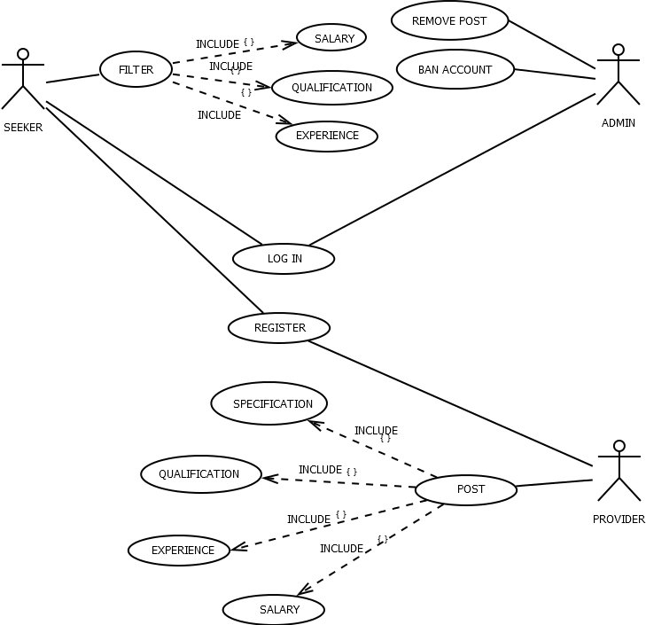

**CLASS DIAGRAM**

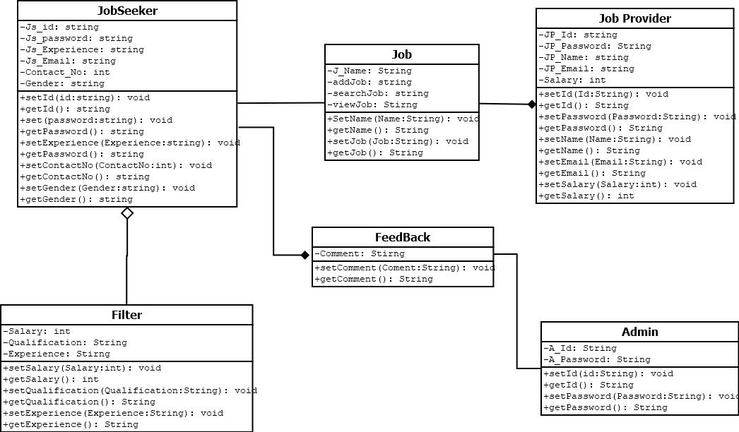

**ER DIAGRAM**

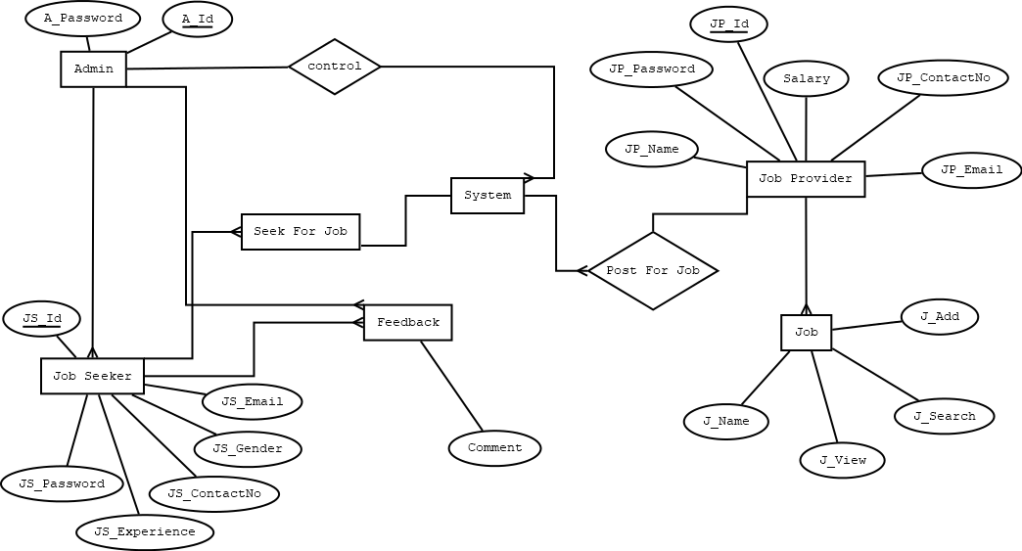

**ACTIVITY DIAGRAM**

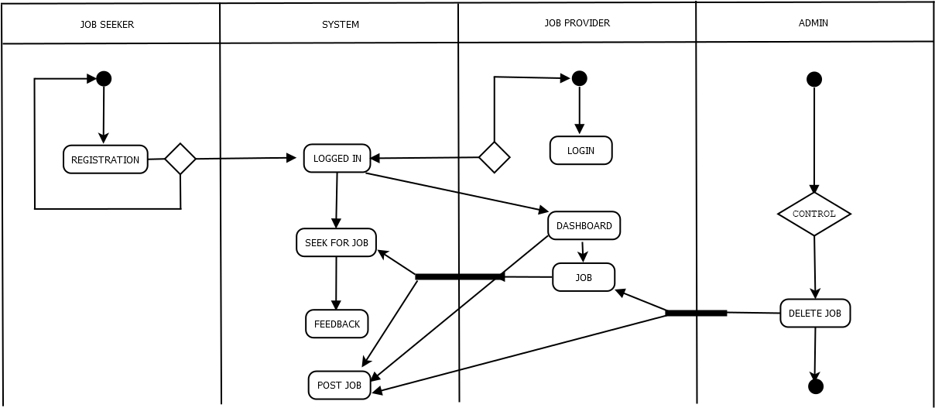

**STATE CHART DIAGRAM**

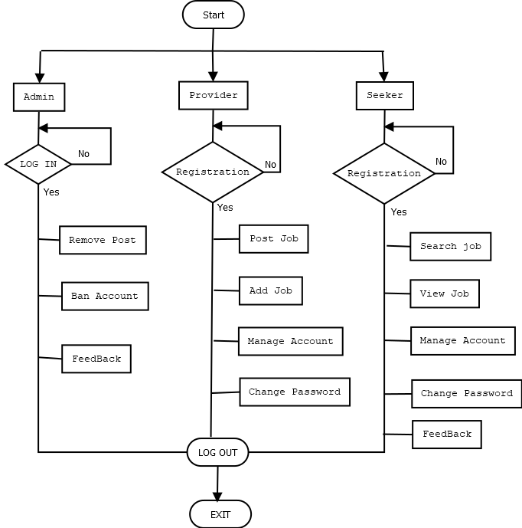

### 3.4 System Interface:

**Home Page**

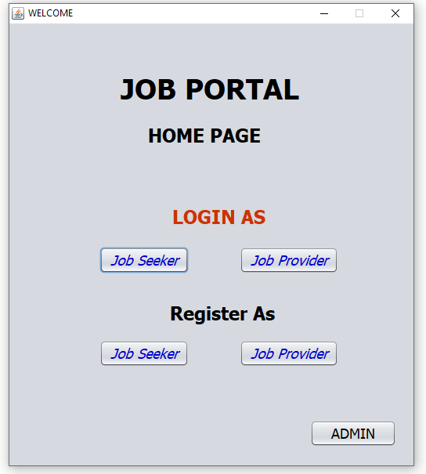

**Job Provider Registration page**

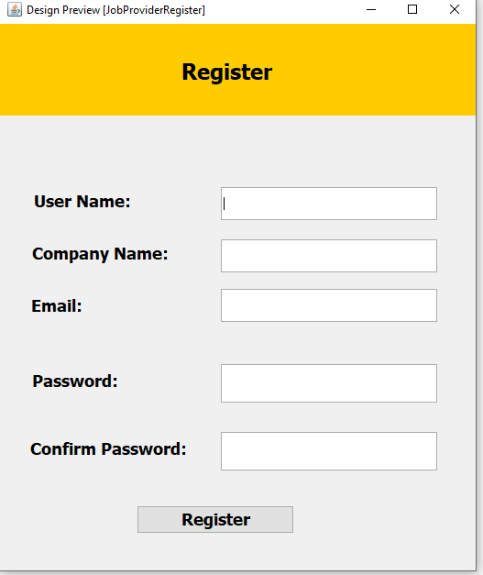

**Job Seeker Registration page**

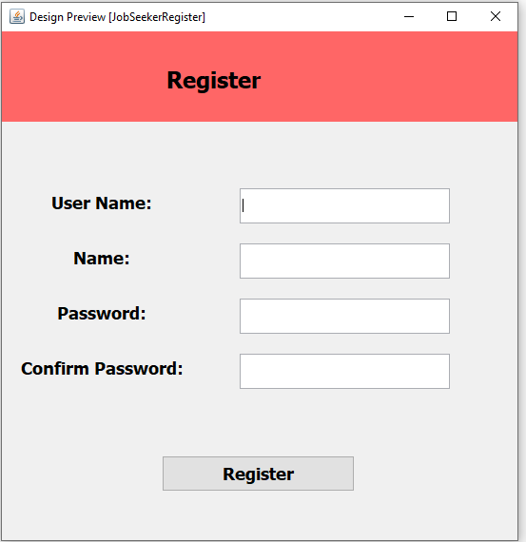

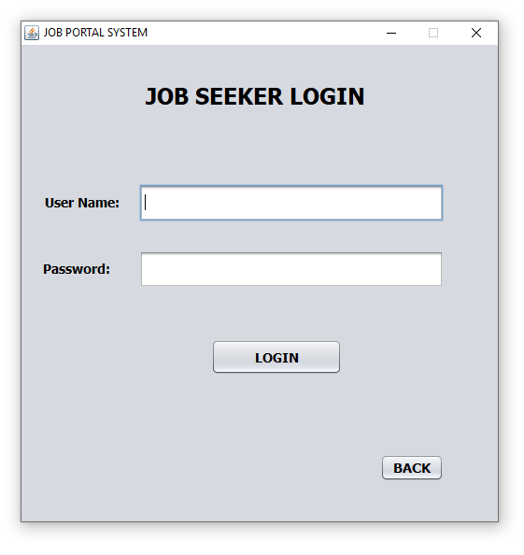

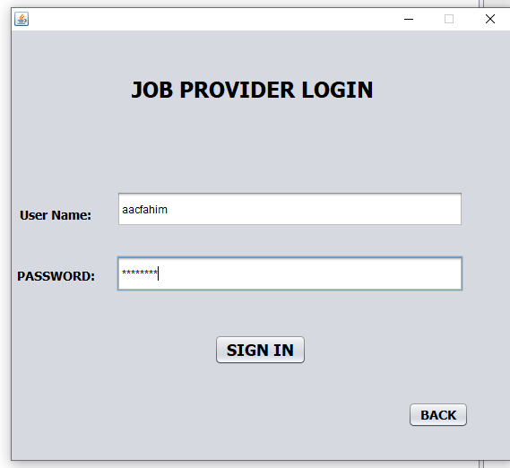

**Job Provider’s Dashboard**

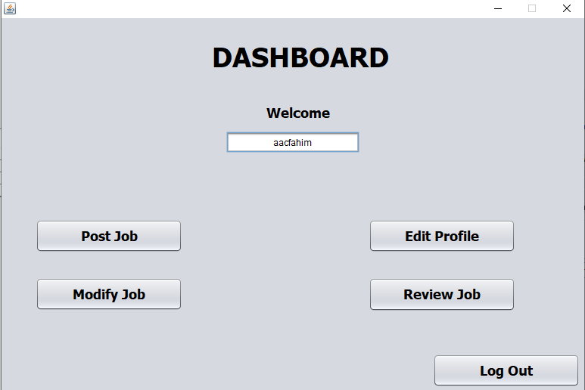

**Posting jobs as job provider**

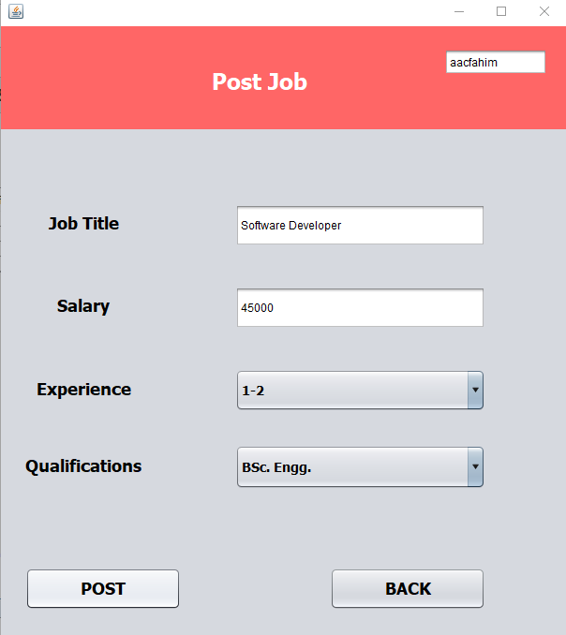

**Post searching as job seeker**

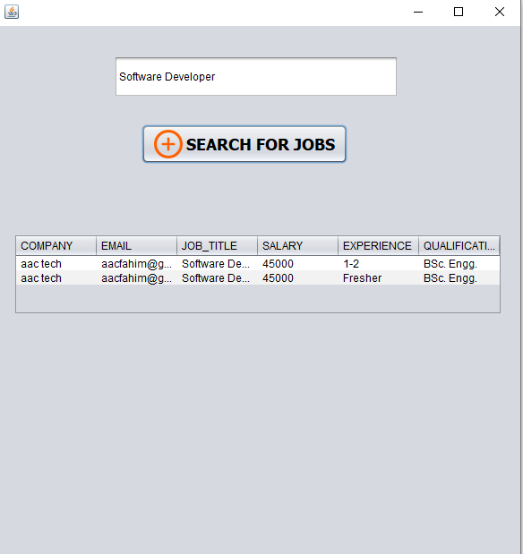

### 3.5 Project Requirements

In Organic Mode

30000 LOC

Effort = 2.4 * (30 kloc) ^ 1.05

= 85.35

Delivery Time = DM = 2.50 * (85.35) ^ 0.38

= 13. 54

= 14 PER PERSON – DAY

Required Member = 85.35/13.54

= 6.30

### 3.6 References

1. "Kormo - Build a CV, Find jobs & Grow your career", Kormo, 2019. [Online]. Available: <https://www.kormo.com/>
2. "Largest Job Site in Bangladesh, Search Jobs | Bdjobs.com", Bdjobs.com, 2019. [Online]. Available: <http://www.bdjobs.com/>
3. "A Project Report On Online Job Portal – 1000 Projects", 1000projects.org, 2019. [Online]. Available: https://1000projects.org/project-report-online-job-portal.html.
4. "Manifesto for Agile Software Development", Agilemanifesto.org, 2019. [Online]. Available: <https://agilemanifesto.org/>
5. "R.S. Pressman & Associates, Inc.", Rspa.com, 2019. [Online]. Available: <http://www.rspa.com/>
6. Bandari, S. Sarita, S. Babu, M. Chaudhary, A. Team and G. Man, "What Are The Quality Attributes?", Softwaretestinghelp.com, 2019. [Online]. Available: <https://www.softwaretestinghelp.com/what-are-the-quality-attributes/>